AI Search Visibility Report: Café Athena vs. Pacific Beach Competitors
Benchmark Restaurant: Café Athena, Pacific Beach, San Diego
Competitors: JRDN, Slowly, Spitz, and Waterbar
Research Date: October 23, 2026

1. Executive Summary
This report evaluates Café Athena's visibility in AI-generated restaurant recommendations compared with four competitors in Pacific Beach, San Diego: JRDN, Slowly, Spitz, and Waterbar.
The analysis combines AI search testing, competitor website research, publicly available Google business information, and an assessment of digital content strategies.
Across five customer queries tested on ChatGPT and Claude, Slowly achieved the highest confirmed mention rate at 60%, followed by Café Athena at 50%. JRDN and Spitz each received 30%, while Waterbar received 10%.
These findings indicate that Café Athena already has a meaningful presence in the tested AI recommendations. However, the restaurant has opportunities to improve how its services and dining experiences are communicated online.
Competitor research identifies three main opportunities: more specific dining occasion content, clearer group-event information, and consistent third-party business information.
The report recommends improving Café Athena's existing digital content and developing practical website copy, FAQ content, and structured data to support discoverability.

2. AI Search Visibility Scorecard

2.1 Testing Methodology
We evaluated Café Athena's AI search visibility against four competitors using two AI platforms: ChatGPT and Claude.
Five consumer queries were tested on each platform, producing ten search responses.
Search Queries
- Best Greek food in Pacific Beach
- Mediterranean restaurant with gluten-free options in San Diego
- Happy hour with good food near Garnet Ave
- Where to host a rehearsal dinner in Pacific Beach
- Date night spot in PB with good cocktails
Evaluation Metrics
- Confirmed Mention Rate: Number of responses recommending a restaurant divided by the number of queries tested.
- Average Recommendation Rank: Average position when a restaurant appears in an explicitly ordered recommendation list.
- Competitor Share-of-Voice: Percentage of confirmed mentions belonging to each restaurant among the five competitors studied.
- Cross-Platform Visibility: Differences between ChatGPT and Claude recommendations.
The results use the main written recommendations rather than Google Maps cards embedded in AI responses. Incomplete screenshots are treated as partially observed, so the confirmed counts represent minimum observed appearances.

2.2 Confirmed Mention Rates

Restaurant | ChatGPT | Claude | Combined
Café Athena | 3/5 (60%) | 2/5 (40%) | 5/10 (50%)
Slowly | 4/5 (80%) | 2/5 (40%) | 6/10 (60%)
JRDN | 2/5 (40%) | 1/5 (20%) | 3/10 (30%)
Spitz | 2/5 (40%) | 1/5 (20%) | 3/10 (30%)
Waterbar | 0/5 (0%) | 1/5 (20%) | 1/10 (10%)
Source: ChatGPT and Claude test results recorded October 23, 2026.
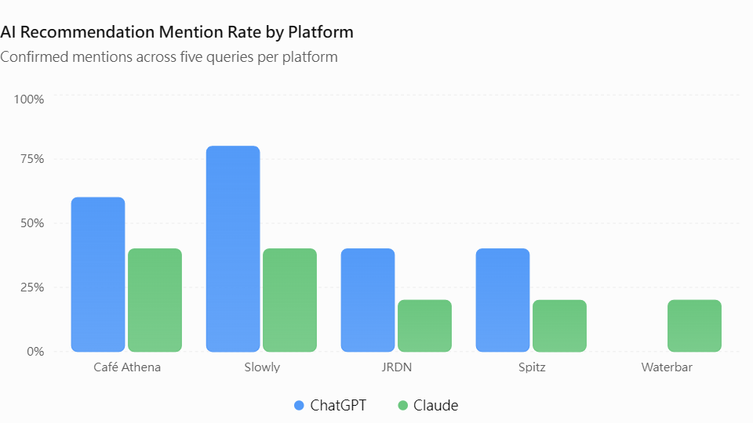

2.3 Competitor Share-of-Voice
Share-of-voice was calculated using 18 confirmed mentions across the five restaurants.
Restaurant | Confirmed Mentions | Share-of-Voice
Café Athena | 5 | 27.8%
Slowly | 6 | 33.3%
JRDN | 3 | 16.7%
Spitz | 3 | 16.7%
Waterbar | 1 | 5.6%
Percentages are rounded. This measures share among the five selected restaurants, not the entire Pacific Beach restaurant market.

2.4 Rank Performance
ChatGPT: positions #1, #1 and #1. Claude: positions #1 and #3. This chart excludes searches where Café Athena was not visibly ranked.

Search intent | ChatGPT | Claude
Greek food | #1 | #1
Gluten-free Mediterranean | #1 | #3
Happy hour | #1 | Not mentioned in written recommendations
Rehearsal dinner | Not confirmed in visible results | Not mentioned
Date night with cocktails | Not in top 5 | Not mentioned
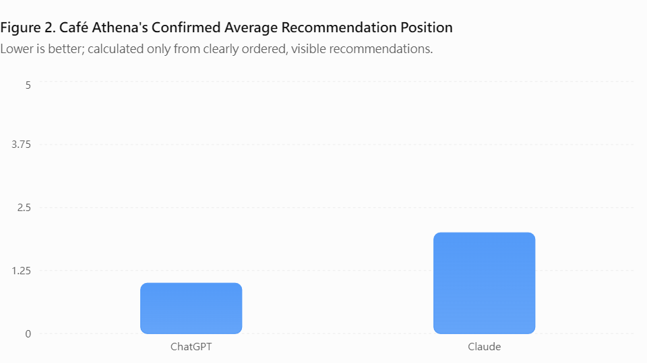

2.5 Visibility Findings
Slowly achieved the highest confirmed mention rate across the tested queries, appearing in six of ten responses. Café Athena followed with five appearances.
Café Athena performed better on ChatGPT than Claude, with confirmed mention rates of 60% and 40%, respectively. This suggests that visibility can differ between AI platforms.
Waterbar had the lowest confirmed mention rate despite its strong online positioning around beachfront dining and happy hour. This shows that restaurant website characteristics alone do not necessarily predict performance across a small AI search test.
Overall, the results suggest that Café Athena has an existing foundation for AI discovery but could strengthen its visibility for specific customer needs.

3. Competitor Gap Analysis: Why Competitors May Win
The visibility results were compared with competitor website content and publicly available restaurant information to identify possible reasons for differences in AI recommendations.

3.1 JRDN — Experience-Based Positioning
Website: https://www.t23hotel.com/jrdn
JRDN focuses on upscale oceanfront dining, sunset views, cocktails, and special occasions.
Its content directly matches searches involving romantic dinners, ocean views, and celebrations.
JRDN also benefits from its association with Tower23 Hotel and third-party dining platforms such as OpenTable.
Its private-event information includes published capacity for approximately 15–150 guests, professional event planning, valet parking, and hotel room blocks.
Potential Advantage: JRDN provides specific information that can help search systems connect the restaurant to event and occasion-related questions.
Opportunity for Café Athena: Publish verified event capacity, group menus, seating arrangements, and celebration packages.

3.2 Slowly — Detailed Content and Search Intent
Website: https://slowlysd.com/
Slowly provides specific information about menu items, cocktails, promotions, and dining experiences.
Its website highlights Tuesday date-night specials, Thursday Aperitivo, Social Hour, signature dishes, and group dining.
It also includes customer-focused FAQ content and publishes private-dining arrangements for different group sizes.
Potential Advantage: Slowly provides detailed answers to a wider variety of customer searches rather than relying only on general Mediterranean restaurant keywords.
Opportunity for Café Athena: Strengthen content for date nights, group dinners, happy hour, and signature Mediterranean dishes.

3.3 Spitz — Local SEO and Restaurant Discovery
Website: https://spitz-restaurant.com/locations/pacific-beach
Spitz has a dedicated Pacific Beach location page containing restaurant details, opening hours, online ordering, catering, and amenities.
It is also represented across restaurant discovery categories related to Mediterranean cuisine, Greek food, and various dietary preferences.
Potential Advantage: Location-specific information and broad cuisine descriptions may support relevance for different local dining searches.
Opportunity for Café Athena: Review its local business categories, dietary descriptions, and consistency across its website and restaurant directories.

3.4 Waterbar — Happy Hour and Experience-Based Positioning
Website: https://waterbarsd.com/
Waterbar emphasizes beachfront dining, ocean views, seafood, cocktails, and happy hour.
Its positioning connects with customers searching for scenic dining, social gatherings, sunset dinners, and beachfront restaurants.
Potential Advantage: Specific experience-based descriptions may help Waterbar match searches about ocean views, drinks, and social dining.
Opportunity for Café Athena: Develop stronger messaging around its own distinctive experiences, including Greek cuisine, Mediterranean small plates, and neighborhood dining.

3.5 Competitor Evidence Matrix
Evaluation Factor | Café Athena | Competitor Evidence | Potential Gap
Dining positioning | Greek and Mediterranean dining | JRDN: oceanfront and romantic experiences | Occasion-based messaging
FAQ content | Coverage needs a complete audit | Slowly: detailed questions and answers | Clearer customer FAQs
Location SEO | Pacific Beach location information | Spitz: dedicated location page | Local content specificity
Happy hour | Offers happy hour | Waterbar: prominent happy-hour positioning | Promotion visibility
Private events | Group dining information available | JRDN and Slowly: published capacities | Detailed event information
Third-party presence | Listings require full audit | Competitors appear across dining platforms | Consistency and completeness
Structured data | Implementation not verified | Competitor implementations not verified | Technical audit needed

3.6 Main Gap Diagnosis
The competitor comparison suggests that the largest opportunity for Café Athena is not a lack of dining services but how clearly those services are communicated.
JRDN and Slowly provide detailed descriptions of special occasions and group dining. Spitz provides location-specific content, while Waterbar communicates distinct social dining experiences.
Café Athena already has recognizable strengths in Greek and Mediterranean cuisine, dietary options, happy hour, and group dining.
Improving the specificity and organization of this information could help customers and search systems understand when Café Athena is a relevant recommendation.
These findings describe potential visibility advantages. They do not prove that particular website features caused the observed AI search results.

4. Third-Party and Technical Evidence Audit

4.1 Google Business Profile Comparison
The Google business information review compares restaurant ratings, review volume, and business categories.
Restaurant | Google-Attributed Rating | Review Count | Primary Category
Café Athena | 4.6 | 545 | Mediterranean restaurant
JRDN | 4.4 | Approximately 1,600 | Seafood restaurant
Slowly | 4.5 | 126 | Mediterranean restaurant
Spitz | 4.9 | 412 | Mediterranean restaurant
Waterbar | 4.3 | 2,515 | American restaurant
Note: These figures were collected from previously identified Google-attributed public sources, which may have different snapshot dates. They must be checked against the Google Maps screenshots before the table is labeled as a verified October 23, 2026 comparison.

4.2 Google Business Profile Findings
The collected figures suggest that Spitz has the highest customer rating among the five restaurants, while Waterbar has the largest review volume.
Café Athena maintains a positive customer rating and hundreds of reviews, providing a foundation for local discovery.
However, these figures should not be interpreted as direct measures of AI search visibility.
For example, Waterbar has the largest review volume in the collected snapshots but the lowest confirmed mention rate in the AI search test.
This suggests that the relationship between public reviews and AI recommendations may depend on search intent, available information, and platform behavior.

5. Prioritized Visibility Gaps and Action Plan
Based on the visibility test and competitor research, the following actions are recommended.
Priority | Proposed Improvement | Supporting Evidence | Expected Benefit
P1 | Improve event and group dining information | JRDN and Slowly publish detailed event information | Clearer matching for event searches
P1 | Strengthen occasion-based website content | Slowly leads confirmed mentions in the test | Broader relevant query coverage
P1 | Measure AI search performance regularly | Visibility differs across ChatGPT and Claude | Better tracking of visibility changes
P2 | Improve customer FAQs | Slowly provides specific customer answers | Easier information retrieval
P2 | Audit Google and other third-party listings | Differences in public restaurant information | Greater information consistency
P2 | Review structured data and technical SEO | Current implementation unverified | Better machine-readable information
These priorities are proposed based on relevance and expected implementation value. Their impact should be tested after implementation.

6. Generated AI Search Optimization Artifacts
The following artifacts demonstrate how Café Athena could improve its digital content.

6.1 Proposed Website Copy
Greek and Mediterranean Dining in Pacific Beach
Discover Greek and Mediterranean cuisine at Café Athena in Pacific Beach, San Diego.
Whether you are planning a casual lunch, dinner with friends, or a group celebration, Café Athena offers Mediterranean dishes, vegetarian choices, and options for different dietary preferences.
Explore the restaurant's menu, learn about happy-hour offerings, and contact the team for group dining arrangements.
Content Objective: Improve relevance for cuisine-specific, local dining, and occasion-based searches.

6.2 Proposed FAQ Content
Q1: What type of cuisine does Café Athena serve?
Café Athena serves Greek and Mediterranean cuisine.
Q2: Does Café Athena offer vegetarian options?
The restaurant includes vegetarian menu options. Guests should check the current menu for available dishes.
Q3: Does Café Athena offer gluten-free dishes?
Café Athena identifies gluten-free options on its menu. Guests with dietary restrictions should confirm ingredients and preparation practices with the restaurant.
Q4: Does Café Athena offer happy hour?
Yes. Café Athena publishes happy-hour information on its website. Guests should check the current schedule and promotions.
Q5: Can Café Athena accommodate group celebrations?
Café Athena accepts group dining inquiries for celebrations and special occasions. Guests should contact the restaurant for capacity, pricing, and available arrangements.
Content Objective: Provide clear answers to customer questions that may arise during restaurant searches.

6.3 Restaurant Structured Data
A Restaurant JSON-LD example should be prepared with verified business information, including:
- Restaurant name and official website
- Postal address and phone number
- Greek and Mediterranean cuisine categories
- Current opening hours
- Menu URL
[Insert JSON-LD code after validating the information against the official website.]
Technical Objective: Help search engines interpret restaurant information consistently.

7. Implementation and Performance Measurement
Timeline | Proposed Action | Deliverable
Week 1 | Complete baseline and third-party audit | Verified visibility and evidence report
Week 2 | Improve website descriptions and FAQs | Publishable website content
Week 3 | Update listings and review technical SEO | Updated and validated information
Week 4 | Repeat the original AI search queries | Before-and-after scorecard
The same queries, platforms, and evaluation criteria should be used during follow-up testing.
Changes in mention rate, average rank, and share-of-voice should be measured rather than assumed.

8. Conclusion
This analysis compared Café Athena with JRDN, Slowly, Spitz, and Waterbar to identify differences in AI search visibility and public restaurant information.
The AI search testing found that Slowly had the highest confirmed mention rate at 60%, followed by Café Athena at 50%.
Competitor research identified different digital strengths. JRDN emphasizes distinctive dining experiences and events, Slowly provides detailed occasion-based content, Spitz uses location-specific information, and Waterbar highlights beachfront dining and happy hour.
Café Athena already has a strong foundation through its Greek and Mediterranean identity, dietary options, happy hour, and group dining services.
The main opportunity is to make these strengths more specific, searchable, and consistently represented across its website and third-party platforms.
Recommended improvements include stronger occasion-based content, detailed group dining information, clear customer FAQs, accurate business listings, and validated structured data.
The findings are limited to the selected queries, platforms, and public evidence available during the research period. Additional tests are necessary to determine whether the proposed improvements increase AI search visibility.

Appendix — Supporting Evidence
Appendix A: AI Search Test Screenshots
ChatGPT and Claude recommendations for the five tested queries, October 23, 2026.
Appendix B: Google Business Profile Screenshots
Google Maps overview, ratings, categories, and selected customer review evidence for the five restaurants.
Appendix C: Competitor Website Evidence
- JRDN: https://www.t23hotel.com/jrdn
- Slowly: https://slowlysd.com/
- Spitz: https://spitz-restaurant.com/locations/pacific-beach
- Waterbar: https://waterbarsd.com/
Appendix D: Technical SEO Evidence
Schema validation results, indexing checks, and relevant website screenshots when available.

